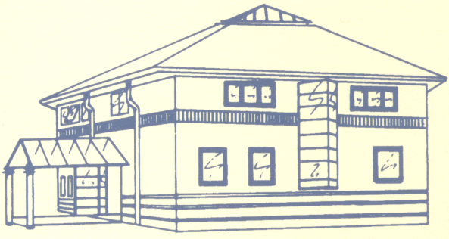
garden lane medical centre

patient newsletter
  - Autumn 2026
TRAINING DAYS

Wednesday 9 September
Thursday 8 October
Wednesday 11 November

GLMC will be closed from 1pm until the following morning at 8am to allow for staff training.

In an emergency, please telephone NHS 111



Autumn FLU & COVID CLINICS 2026
Flu season is once again approaching!
Our Flu clinics for patients aged 65 and over, and for at-risk adults aged 18 to 64, will take place on:
- Saturday 10 October
- Saturday 17 October
- Saturday 24 October
During September, we will offer flu vaccinations to:
- Pregnant women
- At-risk children under 18
- Children who were aged 2 or 3 on 31 August 2026
Invitations for eligible patients receiving their vaccination in September will be sent in due course. Patients eligible from October will be invited over the coming weeks. COVID Vaccines will be offered to all eligible patients at these clinics. Eligible patients include Patients 75 and over and Individuals aged 6 months and over who are immunosuppressed.
As in previous years, invitations will be sent by SMS with a self-booking link, as this system has worked well.

RSV VACCINE EXPANSION
From 1 September 2026, the eligibility criteria for the RSV vaccines will be expanded further to include adults aged 65 to 74 years in certain clinical ‘at risk’ groups, as advised by the Joint Committee on Vaccination and Immunisation (JCVI):
- chronic respiratory disease
- immunosuppression due to disease or treatment
Patients aged 75 or over and pregnant women who are more than 28 weeks gestation also remain eligible for this vaccine.
PATIENT CHAMPION

The Patient Champions Group allows patients to engage with the practice and become more involved.

The next meeting will be 11am-12pm on Tuesday 20 October 2026 at Garden Lane Medical Centre.

If you would like to join the next meeting, please contact gardenlane.reception@nhs.net FAO Janette

NHS HEALTH CHECKS
If you’re aged 40 to 74, you may be eligible for a free NHS Health Check.
You don’t need to be unwell to benefit. The check is designed to help spot early signs of conditions such as high blood pressure, heart disease, stroke, type 2 diabetes and kidney disease — often before you notice any symptoms.
It’s a simple opportunity to:
- Know your numbers, including your blood pressure and cholesterol
- Understand your risk of developing certain health conditions
- Get personalised advice on staying healthy and reducing your risk
- Ask questions about your health and wellbeing
Think of it as an MOT for your health — a chance to find out how you’re doing and what small changes could make a big difference in the future.
If you’re eligible, don’t wait until something feels wrong. Book your NHS Health Check with us today.

5 things to do this autumn to prepare for winter
💉 Check your vaccinations
Find out whether you’re eligible for the seasonal flu and COVID vaccinations and book when invited.
💊 Make sure you have enough medication
Check your repeat prescriptions and order medication in good time, particularly before Christmas or if you’re planning to travel.
🩺 Don’t ignore routine health checks
If you’ve been invited for screening or a health review, take the opportunity to arrange it. Early detection can make a real difference.
🏠 Get your home winter-ready
As the evenings get darker and temperatures drop, check heating, lighting and clear walkways to help prevent falls and keep your home safe.
❤️ Look after your wellbeing
Keep active, get outside during daylight hours, eat well and stay connected with friends and family. Small habits can help support both physical and mental health.

